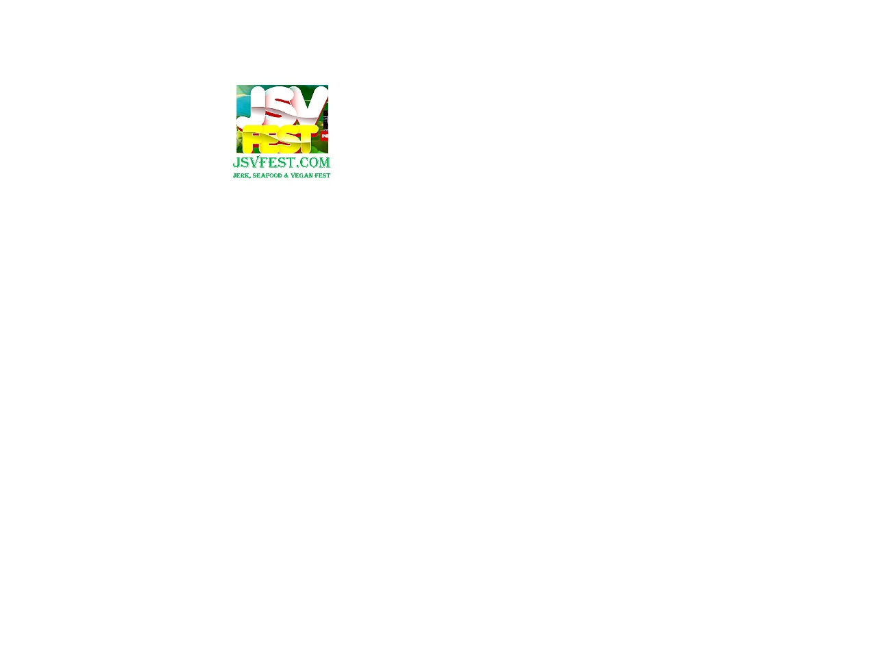**Jerk, seafood &vegan fest (JSVFest)**

**SALUTING MARTIN’S INTERNATIONAL 36th YEAR IN CHICAGO’S SOUTH LOOP**

**A Martin’s International EVENT**

**1325 South Wabash Avenue, #307 Chicago, IL. 60605**

**P: 312/427-0266** www.jsvfest.com **Email:** [**jsvfestival@gmail.com**](mailto:jsvfestival@gmail.com)[www.facebook.com/jerkseafoodveganfest](http://www.facebook.com/jerkseafoodveganfest)[www.twitter.com/jsvfest](http://www.twitter.com/jsvfest)[www.martinsworldmusicradio.com](http://www.martinsworldmusicradio.com)

For Immediate Release

AUGUST 13, 2018, CHICAGO, ILLINOIS:

Do you love to eat, drink, shop and have a good time?  You won’t want to miss the 2nd Annual Jerk, Seafood & Vegan Festival (JSVFest), September 8th and 9th, at the new Park 540, located, 2401 Federal/ Dearborn St with entrance at 2400 S. State Street, Chicago South Loop. Visit www.jsvfest.com.  
  
Food experts will help to select the best Jerk, Seafood and Vegan vendors from the participating restaurants and/or caterers.  
  
Food lovers are talking and asking the question, which restaurant/caterer will be voted the Best Jerk, Best Seafood & Best Vegan Restaurant - 2018 at this year's JSVFest)?  
  
If you are a food expert and want to serve as one of the food Judges, email, jsvfestival.com.  
  
The JSVFest is a family festival of music, food, arts, crafts, corporate branding and more, with over 20 performing acts to entertain the two day fiesta. Among the headlining performers are:

Kevin Lyttle with kits like "Turn Me On", click here https://youtu.be/GP3Exc5tCtc

Sister Nancy "BAM BAM: click here  https://youtu.be/AuupPbyDs7s?t=43

Jack Radics "Twist and Shout", click here https://youtu.be/nAzoSe2kOio

and the Cha Cha Slide creator, Mr. C, the Slide Man, click here https://youtu.be/wZv62ShoStY 

Advance general tickets are only $5 and $10 at gate; VIP tickets are $35 and $50 at the gate.   Get YOUR tix and other information now at [www.jsvfest.com](http://www.jsvfest.com/). You may also email, [jsvfestival@gmail.com](mailto:jsvfestival@gmail.com) or call 877/973-4423 with to enquire about the event.

_________________________________________________